Unit 2 Question Packet
Skill #1: Classifying types of matter

Classify each of the following with the combination of terms listed below.
pure substance – element mixture – homogeneous
pure substance – compound mixture – heterogeneous

1. HCl (aq) ___________________________ 2. sugar ___________________________

3. KBr (s) ___________________________ 4. soil ___________________________

5. Cl₂ (g) ___________________________ 6. water ___________________________

13. Matter that is composed of two or more different elements chemically combined in a fixed proportion is classified as
(1) a compound (2) an element (3) a mixture (4) a solution

14. A compound differs from an element in that a compound
    - is homogeneous (3) has a definite composition
    - has a definite melting point (4) can be decomposed by a chemical reaction

15. A compound differs from a mixture in that a compound always has a
(1) homogeneous composition (3) minimum of three elements
(2) maximum of two elements (4) heterogeneous composition

16. A heterogeneous material may be
  - an element (2) a compound (3) a pure substance (4) a mixture

17. Which statement is an identifying characteristic of a mixture?
(1) a mixture can consist of a single element
(2) a mixture can be separated by physical means
(3) a mixture must have a definite composition by weight
(4) a mixture must be homogeneous

30. The particle diagrams below represent substances at standard temperature and pressure (STP). Place the symbols s, l, and/or g next to the properties which apply in the table below.
Note: two of the properties will have two answers.
Gas (g)

Liquid (l)

Solid (s)

Definite shape |  |  | Takes the shape of its container
Definite volume |  |  | Compressable
Particles in a fixed/rigid geometric pattern |  |  | Expands to fill its container
Most dense |  |  | Least dense

Skill #3: Identifying physical & chemical properties of matter - refer to your notes and RB p. 13

31. Identify the following as either a physical property (P) or a chemical property (C). (Hint: there are only 5 chemical properties listed below, the rest are physical properties.)

a. _____ Magnesium is malleable. | b. _____ Magnesium conducts electricity.
c. _____ Magnesium reacts with an acid. | d. _____ Magnesium has a high boiling point.
e. _____ Iron reacts with oxygen to form rust. | f. _____ Iron forms a compound with chlorine.
g. _____ Salt dissolves in water. | h. _____ Hydrogen gas burns in air.
i. _____ Sodium chloride forms an aqueous  solution. | j. _____ Hydrogen gas has a density of 0.00009  g/cm³ at STP.
k. _____ Hydrogen gas has a boiling point of  -253ºC at standard pressure. | l. _____ Oxygen can combine with a metal to  produce a compound.
m. _____ Oxygen gas is slightly soluble in water. | n. _____ Oxygen gas can be compressed.
o. _____ Compound A is a blue color. | p. _____ Water freezes at 0ºC.
q. _____ Gold can be flattened into sheets. | r. _____ Iron conducts electricity and heat.
s. _____ Copper can be drawn into a wire. | t. _____ Oxygen gas is colorless.

32. A large sample of a solid is crushed into smaller pieces for testing. Which two physical properties are the same for both the large sample and one of the smaller pieces?
(1) mass and density (2) mass and volume
(3) solubility and density (4) solubility and volume

33. Describe one appropriate laboratory test that can be used to determine the malleability of a solid sample of an element at room temperature. [1]
Place the sample on a solid surface. Strike the sample with a hammer several times to see if the sample flattens.
Try to bend the sample to change the shape.

34. Copper is used in home wiring and electric motors because it has good electrical conductivity. Other uses of copper not related to its electrical conductivity include coins, plumbing, roofing, and cooking pans. Aluminum is also used for cooking pans.

At room temperature, the electrical conductivity of a copper wire is 1.6 times greater than an aluminum wire. The heat conductivity of copper is 1.8 times greater than the heat conductivity of aluminum. The density of copper is 3.3 times greater than the density of aluminum.

a. Identify one physical property of copper that makes it a good choice for uses that are not related to electrical conductivity. [1]
Copper is very malleable
OR good conductor of heat
OR high melting point
b. Identify one physical property of aluminum that could make it a better choice than copper for a cooking pan. [1]
An aluminum pan has less mass than a copper pan of the same size because aluminum is less dense
OR Aluminum is less dense than copper
OR A Cu pan would weigh more.

Skill #4: Separating mixtures – refer to your notes and RB p. 2

35. When a mixture of water, sand, and salt is filtered, what passes through the filter paper?

(1) water, only (3) water and salt
(2) water and sand (4) water, sand, and salt

36. Recovering the salt from a mixture of salt and water could best be accomplished by

(1) evaporation (3) paper chromatography
(2) filtration (4) density determination
37. Which mixture can be separated by using the equipment shown below?

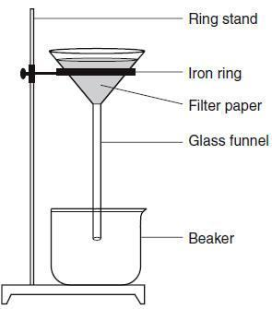
(1) NaCl(aq) and SiO₂(s)
(2) NaCl(aq) and C₆H₁₂O₆(aq)
(3) CO₂(aq) and NaCl(aq)
(4) CO₂(aq) and C₆H₁₂O₆(aq)

Skill #5: converting Temperatures – refer to your notes and RB p. 5

38. Which is not a form of energy?
(1) light (2) temperature (3) electricity (4) heat

43. The temperature of an object changes by 100ºC. The same temperature change in Kelvins would be
Temperature (ºC and K)

(1) 100K (2) 173 K (3) 272 K (4) 373 K

44. The difference between the boiling point and the freezing point of pure water at standard pressure is
(1) 32K (2) 273 K (3) 100 K (4) 373 K

45. Different masses of copper and iron have the same temperature. Compared to the average kinetic energy of the copper atoms, the average kinetic energy of the iron atoms is
(1) 273 K less (2) 100ºC less (3) 273 K more (4) the same

46. The average kinetic energy of water molecules is greatest in which of these samples?
(1) 10 g of water at 35ºC (3) 100 g of water at 25ºC
(2) 10 g of water at 55ºC (4) 100 g of water at 45ºC

47. As the temperature of a substance decreases, the average kinetic energy of its particles
(1) decreases (2) increases (3) remains the same

48. Which change in the temperature of a 1-gram sample of water would cause the greatest increase in the average kinetic energy of its molecules?
(1) 1ºC to 10ºC (2) 10ºC to 1ºC (3) 50ºC to 60ºC (4) 60ºC to 50ºC

Skill #6: Identifying physical & chemical changes in matter clasify the following as either a physical change (P) or a chemical change (C). (Hint: there are only 4 chemical changes listed below, the rest are physical changes.)

a. _____ Freezing | b. _____ Boiling
c. _____ Condensing | d. _____ Evaporating
e. _____ Burning | f. _____ Exploding
g. _____ Dissolving | h. _____ Decomposing
i. _____ Forming an aqueous solution | j. _____ Corroding/rusting
k. _____ Crystallizing | l. _____ Subliming

53. The diagram below represents the starting materials (reactants) and ending materials (products) after a change has taken place. Was the change physical or chemical? Explain. [1]
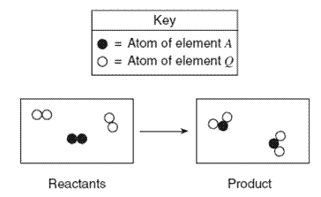
54. Given the particle diagram representing four molecules of a substance:
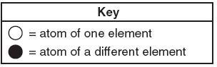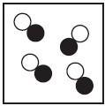
Which particle diagram best represents this same substance after a physical change has taken place?
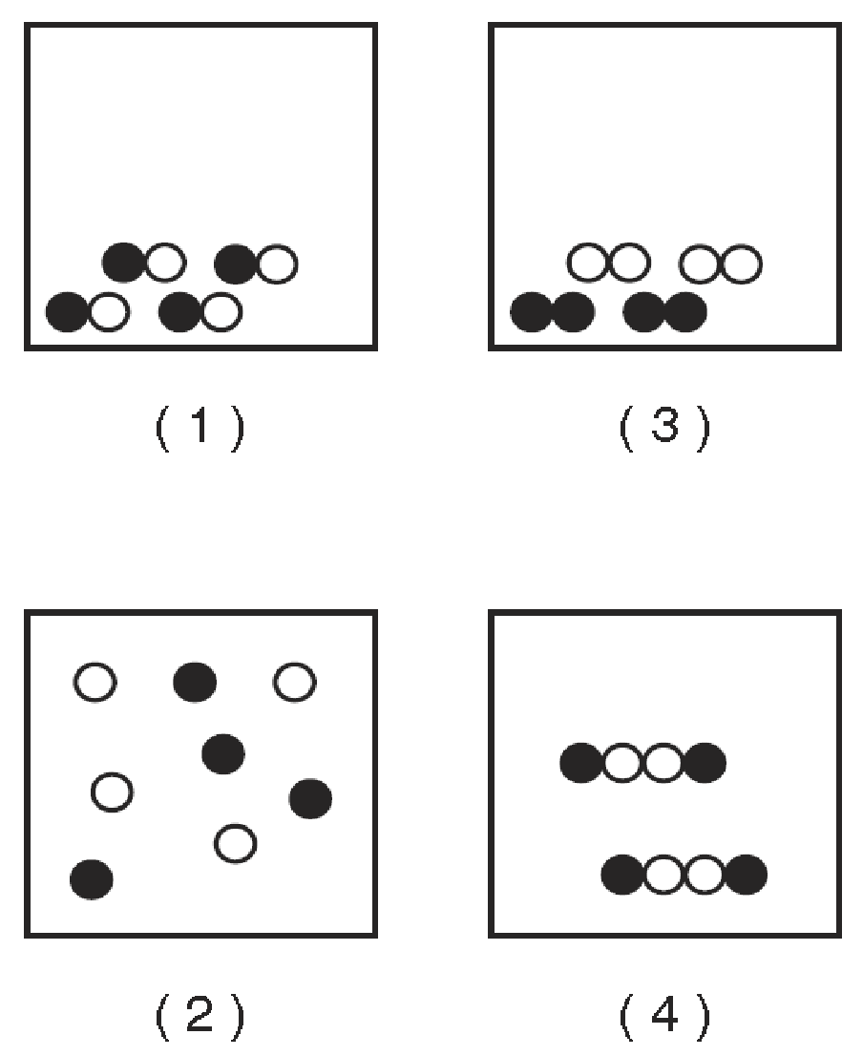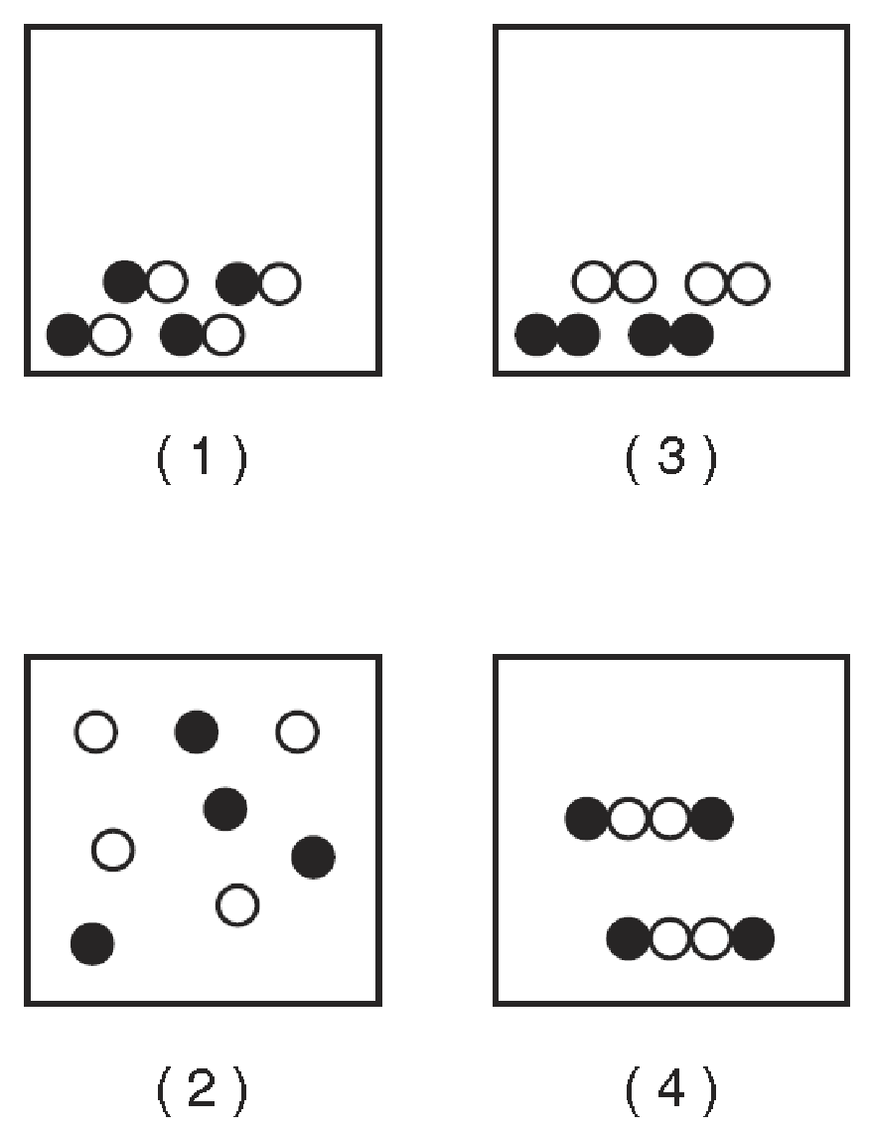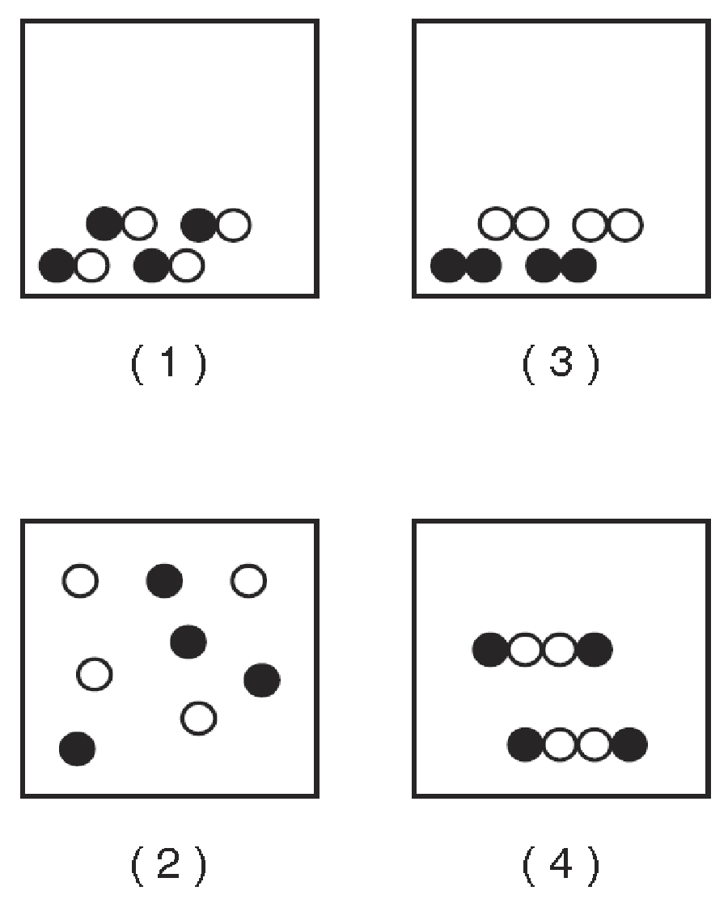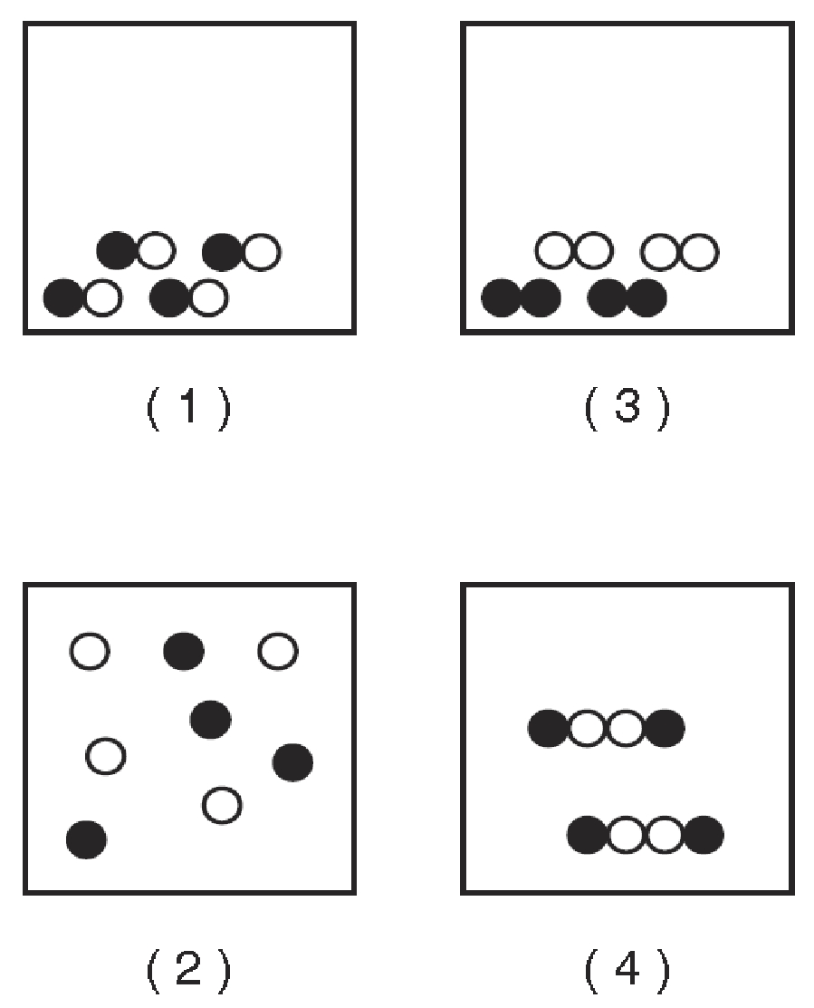

55. In an investigation, a dripless wax candle is massed and then lighted. As the candle burns, a small amount of liquid wax forms near the flame. After 10 minutes, the candle’s flame is extinguished and the candle is allowed to cool. The cooled candle is massed.

- Identify one physical change that takes place in this investigation. [1]
Melting, vaporization, solidification

- State one observation that indicates a chemical change has occurred in this investigation. [1]
The burning candle releases heat and light

